FOR IMMEDIATE RELEASE

Save the date: Veterans' charity summer fayre

The Worthing community is being invited to attend a Summer Fayre in the grounds of Care for Veterans – a Royal Star & Garter Home.

The family-friendly fun day takes place at the care home in Boundary Road on Saturday 4 July, from 12-4pm.

It will include music performances from school, community and British Sign Language signing choirs, plus Rochester Pipes and Drums marching band. Worthing Fire Station’s Red Watch will be present with their fire engine and there will also be a kung fu demonstration. Delicious food and drinks and a variety of market and craft stalls will be available, as will traditional games such as hook-a-duck, spin the wheel, tombolas, play your cards right and bottle hoopla to keep all the family entertained.

Care for Veterans provides long-term nursing, rehabilitation, respite and end-of-life care to veterans and their families who live with disabilities, including acquired brain injury and degenerative neurological conditions. It is now part of the Royal Star & Garter group, following a merger with the charity in 2025.

Entry to the Summer Fayre is by donation, with all proceeds going towards the care and rehabilitation of veterans and their families.

VIPs attending will include Worthing West MP Dr Beccy Cooper, West Sussex High Sheriff Gary Shipton, Worthing Mayor Lysanne Skinner and Worthing town crier Bob Smitherton.

Among those with stalls at the fayre will be metal wall art retailer Rusper and Pines. Owned by husband-and-wife team Kieran and Victoria, Rusper and Pines will be donating a percentage of sales on items sold from their Lest We Forget range of products to Care for Veterans this year.

Vicky Strange is Home Manager at Care for Veterans. She said: “The Care for Veterans Summer Fayre is one of the highlights in our calendar and a great day out packed with fun for all the family. It’s a chance for us to welcome the community who support us to our Home to share the fun with our residents and staff.”

Anyone interested in volunteering at the Summer Fayre, or who would like to donate prizes, such as plants, bottled drinks and boxes of chocolates, can email High Value Events & Corporate Manager clare.silva@careforveterans.org.uk

Care for Veterans is welcoming new residents and has recently launched a Day Care service. For more information on this, or to work at the Home, go to www.careforveterans.org.uk

[Ends]

Captions:

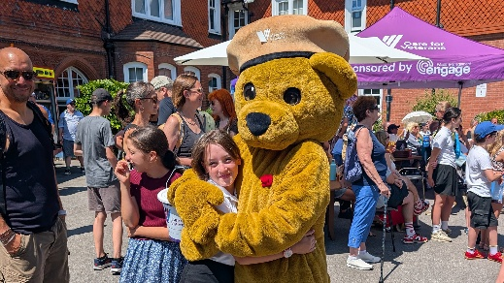 Care for Veterans Summer Fayre 1: One of the guests at the 2025 Summer Fayre receives a big hug from Care for Veterans’ Gifford the Bear

 Care for Veterans Summer Fayre 2: Care for Veterans resident and D-Day veteran Ron watching singers at the Home’s Summer Fayre in 2025

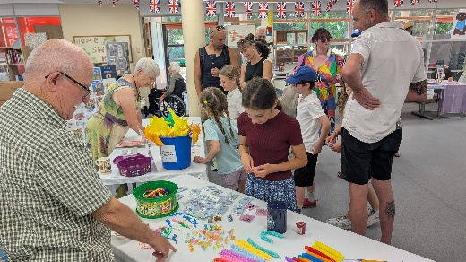 Care for Veterans Summer Fayre 3: Busy stalls in the Wellbeing Hub during last year’s Care for Veterans’ Summer Fayre

For further information please contact:

Emily Abbott
Marketing and Communications Office
emily.abbott@careforveterans.org.uk
01903 790 353

Goolistan Cooper
Communications Officer
goolistan.cooper@starandgarter.org
07391 868796

About the Royal Star & Garter group
Founded in 1916, Royal Star & Garter provides care, support and friendship for veterans and their families so that they can live well. The charity delivers nursing and dementia care through Homes in Solihull, Surbiton, High Wycombe, and now in Worthing, having recently merged with the military charity Care for Veterans. It also offers a range of services reaching into the community, including Lunch Clubs, Day Care and a national Telephone Friendship Service.

