Marathon runners raise money for disabled veterans

The Virgin Money London Marathon is one of the biggest fundraising events in Great Britain, and this year The Royal Star & Garter Homes was represented by two runners determined to raise funds for the Charity they feel so passionately for.

The 26.2-mile course was completed by Matt Petersen, a member of the Body of Governors for the Charity and Andrew Ranson, a former Army Reservist.

Matt Petersen, an Army Officer for over 31 years, both regular and reserve commented, “I’m very excited to be running for such an iconic charity. It is a privilege to wear The Royal Star & Garter Homes’ emblem on my chest and raise money for ex-servicemen and women who have done so much for us.”

Andrew Ranson, commented, “I am keen to support a charity in my local community. The Royal Star & Garter Homes appeals to my Army Reserves background plus the fact I was so impressed with the facilities and fantastic care the Charity provides. I watched the Surbiton Home being built and that was what got me wanting to find out more.”
Matt Petersen
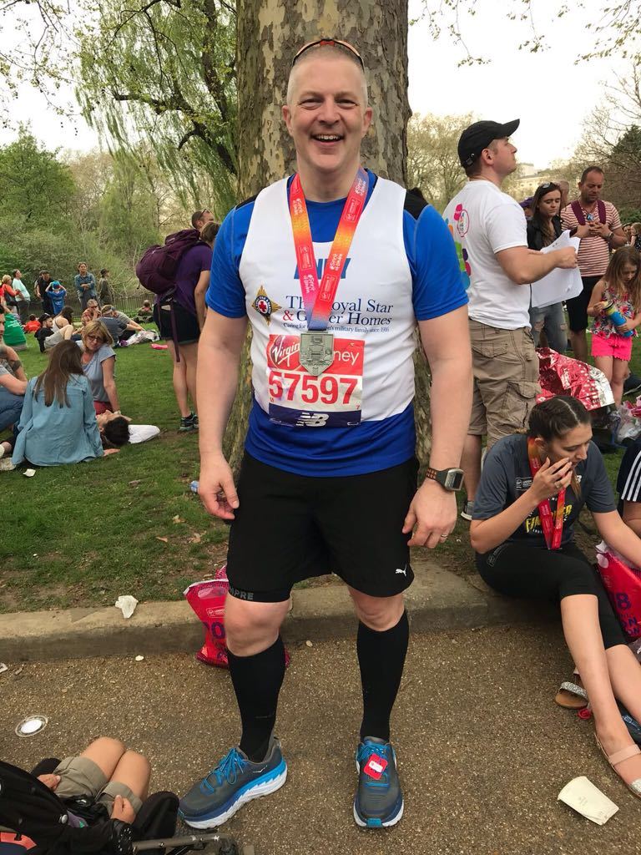
After a gruelling run through London in record-breaking heat, Matt completed the course in 5 hours and 14 minutes, while Andrew finished in 6 hours and 44 minutes.

So far over £3,500 has been raised for the Charity which will go towards providing award-winning care for veterans and their partners who live with disability or dementia in state-of-the-art homes in Surbiton and Solihull.

Andrew Ranson

Ends

